Virginia SOL Synthetic Biology Curriculum
This curriculum has been developed by the iGEM team at the College of William & Mary. If you have any questions regarding this curriculum, please contact the iGEM team at igem@wm.edu

Introduction

In 2018, the state of Virginia updated the Science Standards of Learning (SOL). Our 2018 iGEM team was able to participate in this rewrite after a team member submitted a proposal to include synthetic biology in the updated SOL. The updated SOL now reads:
  - BIO.5 The student will investigate and understand that there are common mechanisms for inheritance. Key ideas include...Synthetic Biology has biological and ethical implications
Synthetic biology is an interdisciplinary and powerful emerging field of science that has wide reaching effects and applications in technology, medicine, and bioremediation. In order to build knowledge of and familiarity with synthetic biology, students should be introduced to these topics earlier in their education rather than stumble across the topic in higher education. This curriculum is designed to introduce students to key topics in genetics such as DNA structure and replication, gene expression, and genetic engineering in order to introduce synthetic biology. Each lesson consists of a beginning discussion, an engaging activity, a lab activity, and a reflection. These lessons are intended to engage students and foster their motivation to learn more about genetics and synthetic biology.

DNA Discovery & Structure

Relevant SOL
BIOL.5 The student will investigate and understand that there are common mechanisms for inheritance. Key ideas include
A: DNA has structure and is the foundation for protein synthesis
B: The structural model of DNA has developed over time

Learning Objectives
Students will learn about the discovery of DNA and its structure through discussion and a variety of activities.
Students will understand the:
- History and process of DNA discovery
- Structure of DNA
- Important terms including
  - Chargaff’s rule
  - Double Helix
  - Nucleotide Base
  - Phosphate Backbone
  - Anti-parallel

Background
Credit for the discovery of DNA structure is often given to James Watson & Francis Crick, however many other scientists’ work made their findings possible. DNA was discovered in 1869 by the Swiss physiological chemist Friedrich Miescher when he identified what he called ‘nuclein” inside the nucleus of human white blood cells. Meishcer had discovered nucleic acids. However, his discovery was not appreciated within the scientific community, and new research slowed until the 20th century. Phoebus Levene picked up research on the “nuclein” in the 20th century. Levene discovered the three major components of a nucleotide, phosphate, sugar, and base; defined the carbohydrate part of DNA, the deoxyribose sugar; and identified how RNA and DNA molecules are combined. Erwin Chargaff furthered Leven’s research by finding that the nucleotide sequence of DNA varies between species, but DNA retains certain qualities. This second discovery became known as “Chargaff's Rule.” Chargaff’s Rule states that the number of purines (A and G bases) is equal to the number of pyrimidines (T and C) bases. These discoveries paved, along with advances in X-ray crystallography by Rosalind Franklin and Maurice Wilkins, paved the way for Watson and Crick. Watson and Crick proposed the double helix structure and created the first correct DNA structure model.

Main features of DNA structure
- DNA is a double stranded helix in which two strands are connected by hydrogen bonds between nitrogenous bases.
- The four bases are Adenine (A), Thymine (T), Guanine (G), and Cytosine (C). The bases pair up in order to bind the two strands. The nucleotide base pairs must be Adenine and Thymine (AT) and Guanine and Cytosine (GC).
- DNA strands have directionality due to the structure of the nucleotides in the chain. The beginning of the chain starts at the 5 prime (5’) end where the 5’ phosphate group is. The other end is the 3 prime (3’) end where the 3’ end of the sugar is.
- The DNA double helix is antiparallel, which means the 5’ end of one strand is paired with 3’ end of the complementary strand.
- The DNA backbone consists of a phosphate, deoxyribose sugar, and a nitrogenous base. The base pairs form hydrogen bonds to adhere the two strands together.
- Nucleotides consist of a phosphate bonded to a sugar and a nitrogenous base by covalent bonds.
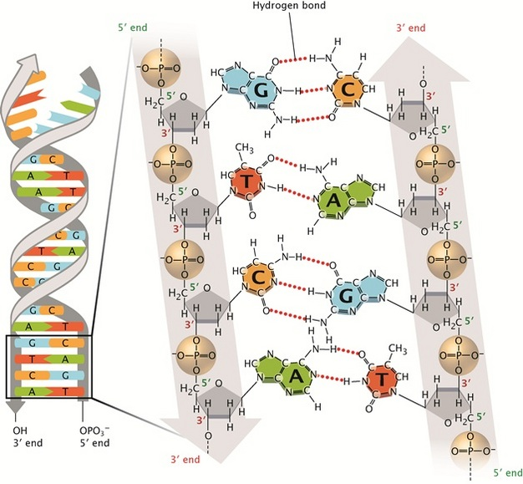
Image from https://www.nature.com/scitable/topicpage/discovery-of-dna-structure-and-function-watson-397

Teacher Actions
Pre-knowledge questions:
What is DNA?
What is the function of DNA?
Who discovered DNA?
Who discovered DNA structure?
What does DNA look like?
Ask students to draw what they think DNA looks like
- Lecture on the information provided in the background section, or have students research DNA discovery and structure individually, or in small groups
  - Students should take notes during the lecture and/or research to help with the class discussion and pre-knowledge questions
- Lead a class discussion an DNA discovery and structure by asking the students the pre-knowledge questions, about or have students discuss the topic and answer the questions in small groups.
- Students should be able to answer all the pre-knowledge questions before beginning the activity
- Transition into the I Am a Nucleotide Movement Activity
- Following the movement activity, have the students draw the structure of DNA and reflect on what they learned during the lesson.
- Transition into one of the lab activities.
- At the end of class, or for homework, have students reflect on what they’ve learned and how this knowledge can be applied outside of the classroom.

Resources
- https://www.nature.com/scitable/topicpage/discovery-of-dna-structure-and-function-watson-397
- Dorji, Karma & Sriwattanarothai, Namkang & Namgay, Ugyen. (2018). I am a Nucleotide Activity: An Approach to Understand Deoxyribonucleic Acid (DNA) Molecule. 10.13140/RG.2.2.20919.16800/10.
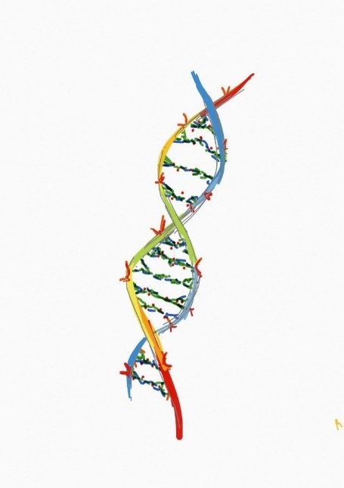
- Illustrations courtesy of Warwick iGEM
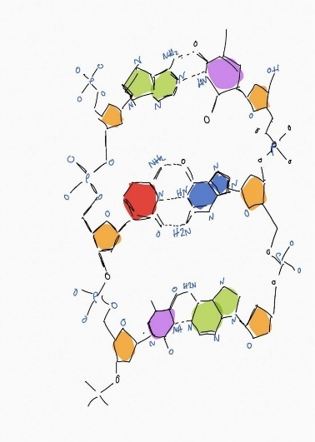

Activities
I Am a Nucleotide Movement Activity
In this activity, students represent the individual nucleotides. Their right fist represents a nitrogenous base, their shoulder represents the sugar, and their left fist represents the phosphate.

Materials
Students
Skin-safe markers
Flash cards

Protocol
- Move through the class and write a nitrogenous base letter (A,T,G, or C) on each student’s right fist. If students do not want writing on their hands, give each student a flash card with a nitrogenous base letter instead. Make sure to have an equal number of complementary bases.
- Start with your arms down at your sides.
- Say “I am a nucleotide”
- Say “I have a phosphate on my fist” As you say this, extend your left arm as shown. Your left hand should stay extended through step 6.
- “I have sugar on my shoulder” [students echo]. While speaking, pat your left shoulder with your right hand.
- “And I have a nitrogenous base.” Extend your right arm as shown.
- “I am a nucleotide. Move into the form shown below to create the two stranded DNA model.
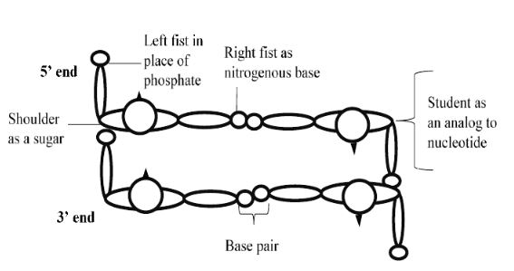
Lab Activities
Cheek Cell DNA Extraction
Students will extract their own DNA from cheek cells to get a tangible sense of what DNA looks like on a macroscopic scale.

Materials
Per student:
5 mL Lemon-Lime Gatorade (original)
5 mL 95% ethanol
2 mL 25% detergent (dilute in water)
Small disposable cup
15mL test tube
One wooden skewer or popsicle stick

Procedure
- Take the 5 mL aliquot of Gatorade and swish it around your mouth like mouthwash for 30 seconds.
- Spit it back into the cup and transfer it into your tube.
- Add 2 mL of the 25% dishwashing detergent solution, cap/stopper the tube, and invert gently several times to mix. Do not shake!
- Let the tube sit for a few minutes so the solution can work and to allow bubbles to pop.
- Hold the tube at an angle and VERY slowly pour the ice cold ethanol down the side of the tube. You should see a clear layer forming on top of your Gatorade layer. Be very careful not to shake or jostle the tube! Within a few seconds, you should see a white filmy layer between the Gatorade and ethanol layers. This is the DNA!
- Without shaking the tube, gently slide a skewer all the way to the bottom of the tube and slowly spin it. You will see the DNA start to stick to the skewer. Slowly pull the skewer out.
- You can dry the DNA on the skewer or collect it into a microcentrifuge tube using a toothpick to keep as a souvenir!

What is happening in this experiment?
The Gatorade is isotonic to our own cells so the salt concentration is similar in Gatorade and our own cells. This helps to ensure that the cells don’t lyse before we want them to. Since the cells in our mouth are loosely attached, we can get enough cells by swishing Gatorade around. The detergent is added because it is amphipathic, which means that it has one end that is hydrophobic (repels water) and one side that is hydrophilic (attracts water). Since the membrane in each cell is composed of a lipid bilayer with both hydrophobic and hydrophilic parts, the detergent incorporates into the lipid bilayer and causes it to fragment. It can also surround proteins to break up interactions and aid in ultimately releasing the DNA from the cell. It is important to remember “like dissolves like” when talking about polarity. DNA is very polar and has a net negative charge in solution and therefore will dissolve in other strong polar molecules. Ethanol is added since ethanol is less polar. Since DNA is highly polar it is unable to dissolve in the much less polar ethanol so it precipitates instead when ethanol is added.

Fruit DNA Extraction

Materials
1/4 of a banana or 1 large strawberry
Ziploc bag with 1 inch of water
Detergent
Disposable cup with two coffee filters
Ethanol (refrigerate before use)
One popsicle stick

Procedure
- Give each student (or pair of students) 1/4 of a banana or a strawberry in an open ziploc bag with water and close the bag.
- Tell students to gently mash up the fruit by squeezing the bag.
- Once the banana is a lumpless mush, put some detergent into each bag and close the bag.
- Students should gently mix in the detergent, trying to avoid creating bubbles.
- Give each student or pair a disposable cup with two coffee filters taped to the top.
- Carefully pour the contents of the bag into the coffee filters and let the liquid drip through the filter into the cup.
- Let the fruit-detergent mix sit in the cup for 20-30 minutes.
- The DNA Extraction will work without filtering the fruit-detergent mixture. If you are not using a filter, pour the fruit-detergent mixture into the cup and skip to step 10.
- Throw away the coffee filters and any material that didn’t drip through the filter, keeping the cup and the liquid that collected in it.
- Pour cold ethanol into the cup and try not to disturb the surface of the fruit liquid. You should see a layer of ethanol on top of the fruit liquid. The more you pour in, the more DNA will precipitate out of the liquid.
- Use the toothpick or skewer to stir the white-clear substance that precipitates out or collects at the top of the liquid: this is the DNA!

DNA Replication

Relevant SOL
BIO.5 The student will investigate and understand that there are common mechanisms for inheritance. Key ideas include
- DNA has structure and is the foundation for protein synthesis;
- the structural model of DNA has developed over time

Learning Objectives
Students will learn about DNA replication through discussion, making concept maps and models, and a lab activity.
Students will understand the:
- Step by step process of DNA replication
- Parts involved with DNA replication
- Important terms including
  - Replication origin
  - DNA helicase
  - Semi conservative
  - Primer
  - DNA Polymerase
  - Primase
  - DNA Ligase
  - Leading Strand
  - Lagging Strand
  - Okazaki Fragments

Background
DNA replication is the process in which a cell copies its own DNA to prepare for replication. It is an incredibly specific and sophisticated process in all cells. Bacterial cells have 1 million to 4 million base pairs of DNA while the common mouse genome contains 3 billion pairs, but the DNA replication process is almost the same in both organisms.
In this lesson, we will focus on DNA replication in bacterial cells. Bacteria have circular chromosomes so they undergo circular replication, while eukaryotes undergo linear replication. They are similar processes, but eukaryotic chromosomes have many replication origins due to their large amount of DNA.

The replication process can be summarized into a few major steps:
- The opening and unwinding of the DNA double helix
- Primer synthesis and the priming of the template strand
- Assembly of the new DNA strand
Before the replication begins, it needs to be initiated. DNA replication is triggered when an initiator protein binds to the replication origin. Next, a protein called DNA Helicase binds to and travels along the DNA strand, breaking apart the hydrogen bonds that hold the strands together. Once the two strands are unwound and separated, replication will proceed on each strand at the same time, but in opposite directions.
Primer synthesis begins the synthesis of the new DNA strand. Primers are short sequences of nucleotides that mark the start of assembly for the new DNA strand. Primers are synthesized on the strand by an RNA polymerase enzyme called Primase. Later in replication, the primers will be removed and replaced with DNA nucleotides.
After the primers are placed, DNA Polymerase attaches to the original strand, the template strand, and assembles a new strand. DNA Polymerase uses free floating nucleotides to create complementary base pairs and build the new strand. DNA is synthesized in the 5’ to 3’ direction, so DNA Polymerase can only move in one direction. One strand, the leading strand, can be synthesized immediately while the other strand, the lagging strand is synthesized in parts. This is called discontinuous replication. The fragments along the lagging strand are called Okazaki fragments, named after the Japanese molecular biologist who discovered them.
DNA replication is semi-conservative which means, after replication, each new double helix contains one strand of old DNA, the template strand, and one newly synthesized strand.
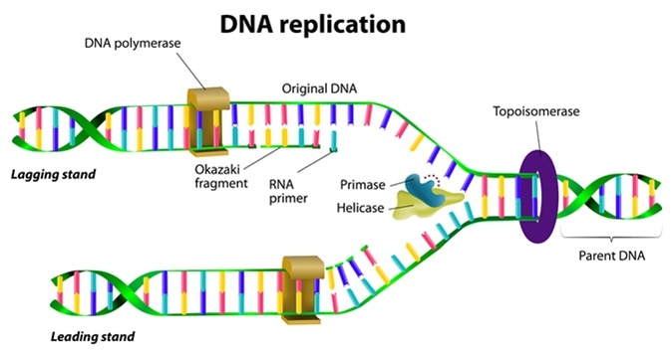

Teacher Actions
Students should have prior knowledge of
- the structure and function of DNA
- the structure of prokaryotic and eukaryotic cells
- the process of cell replication and the cell cycle
- when DNA replication occurs in the cell cycle
Pre-knowledge Questions:
What is the structure of DNA?
What is the function of DNA?
Why does DNA replicate?
Where in a Prokaryotic cell does DNA replicate?
Where in a Eukaryotic cell does DNA replicate?
When does DNA replicate?
Is DNA replication always perfect?
- Begin the class by playing the following video to engage the students and help them visualize the process of DNA replication.
  - https://www.youtube.com/watch?v=TNKWgcFPHqw
- Students should take notes during video to help them during the discussion
- Discuss the video with the students
  - What did they see in the video?
  - What did they recognize or already know?
  - What was new information?
- Lecture on the information provided in the background section, or have students research DNA replication, or in small groups
- Students should be able to answer all the pre-knowledge questions before beginning the activities
- Transition into creating a concept map or the yarn replication activity
  - Students could choose which activity they would like to complete, or an activity can be assigned to individual students or the entire class
  - Students may benefit from looking at the image from the background section, or a similar image, while making their model
- Students that complete the concept map should share their model with the class or in small groups
- Students that complete the yarn model should demonstrate the process of DNA replication, using their model, to a partner
- (Optional) Transition into the lab activity
  - Before beginning the lab activity, introduce PCR to the students through a video or lecture
  - These activities require considerable preparation and time to complete.
  - Extra time will need to be set aside for these activities in class
  - The manual PCR takes approximately 3 hours to complete
- If completing the lab activities isn’t possible in the classroom, show the students a video of the process and have them research and discuss lab techniques for DNA replication.
  - 2 Minute Video: https://www.youtube.com/watch?v=hO3mTqrEeq8
  - 3 Minute Animation: https://www.youtube.com/watch?v=iQsu3Kz9NYo
- At the end of class, or for homework, have students reflect on what they’ve learned and how this knowledge can be applied outside of the classroom.

Resources
- https://www.nature.com/scitable/topicpage/cells-can-replicate-their-dna-precisely-6524830/
- https://www.nature.com/scitable/topicpage/major-molecular-events-of-dna-replication-413/
- https://www.nature.com/scitable/topicpage/dna-replication-and-causes-of-mutation-409/
Image from https://www.news-medical.net/life-sciences/DNA-Replication-and-Repair.aspx

Activities
Image Based Concept Map
Concept maps are useful tools to synthesize your knowledge of a subject. In this concept map, you will draw a diagram of the DNA replication to show your knowledge of the process. This concept map should be image based and include the least amount of words possible.

Materials
- Writing utensil
  - Multiple colors may be useful
- Paper

Protocol
- In the middle of your piece of paper write DNA Replication and draw an image to represent that.
- Around DNA replication, draw and write concepts that describe the elements and process of DNA replication.
- This could include
- The major events in DNA replication
- Elements of the replication process like primers and DNA polymerase
- Once your map is finished, share it with your class and discuss the DNA replication process.

Yarn DNA Replication

Materials
- Paper
- Markers or Colored Pencils
- Scissors
- 3 colors of yarn
- Pom pom balls or paper circles
- Glue or tape (optional)

Protocol
- Cut 2 different colored pieces of yearn
- One color will represent the leading strand
- The other color will represent the lagging strand
- Cut many small pieces of yarn from the third color of yearn. These will represent the Okazaki fragments.
- Pick 3 different colored pom pom balls. They will represent Primase, DNA polymerase, and DNA ligase.
- Model the process of DNA replication with these components by yourself and then to a partner.

Activity adapted from: https://study.com/academy/popular/dna-replication-lesson-plan-activity.html

Lab Activity
PCR
PCR is a technique used to amplify a specific region of DNA. This region is specified by the choice of primers. It generates a high concentration of linear double-stranded DNA fragments.

Materials
0.2mL Tubes
Nuclease Free Water
DNA Sample
10µM Primers
Master Mix

Procedure
- Collect all necessary materials.
- Determine the correct annealing temperature and extension time for your reaction.
- Annealing temperatures and extension times can be calculated from sequences using http://tmcalculator.neb.com/#!/main
- Extension times are calculated based on the length of the intended product. Use 30 seconds per kb for amplicons smaller than 5kb in size. It is usually recommended to round up. Amplicons less than 1kb in size should use 30 seconds extension time. For amplicons larger than 5kb use 50 seconds per kb.
- To a 0.2 mL tube, add 9µL of Nuclease Free Water (NFW), 1µL of DNA sample, and 1.25µL of each primer.
- Add 12.5µL of Master Mix.
- Flick tube to mix, and spin down briefly.
- Turn on the thermocycler
- Program the thermocycler appropriately. To save time, hit edit, go to PCR and set annealing temperature and extension time to the desired values. Hit run. Make sure to put in 25µL for reaction volume.
- Return materials and clean up your workspace. After PCR is finished, visualize on gel to confirm amplification.

Manual PCR
In this module, students will replace the thermal cycler and amplify DNA manually using several hot water baths. PCR is used to amplify a specific region of DNA specified by the choice of primers. It generates a high concentration of linear double-stranded DNA fragments. They will examine how different temperatures interact with the DNA molecules and primers, and how these changing temperatures can be used to conduct a polymerase chain reaction by hand.

Materials
- 2 ml tubes
- DNA Sample
- 10µM Primers
- PCR beads or Master Mix
- Pipettes
- Distilled water
- Thermometers
- Hot water/hot plates
- Several Tupperware containers
- Tongs
- Endurance

Procedure
- This activity requires two water baths: one at 55 degrees C and the other at 98 degrees C. A hot plate may be used to maintain these temperatures, or water can be continually microwaved and switched out.
- Combine 1 uL sample DNA, 2 uL of each 10 uM primers, distilled water, and PCR beads.
- First, and only once, hold the tube in 98 C for 30 seconds.
- Begin cycling as follows. Repeat this cycle 30 times.
- 98 degrees C for 10 sec
- 55 degrees C for 30 sec
- 72 degrees C for 60 sec
- 72 degrees C for 2 min
- After the PCR is finished, visualize your results on a gel.

Gene Expression

Relevant SOL
BIO.5 The student will investigate and understand that there are common mechanisms for inheritance. Key ideas include
c) the variety of traits in an organism are the result of the expression of various combinations of alleles;

Learning Objectives
Students will learn about gene expression through discussion and an activity.
Students will understand the:
- Step by step process of gene expression
- Parts involved in gene expression
- Important terms including:
  - Central Dogma
  - Transcription
  - Translation
  - mRNA
  - RNA Polymerase

Background
You’ve learned that DNA contains your genetic material. Essentially, DNA is the blueprint for living organisms. How is this blueprint built? Through the process of gene expression. Genes encode proteins and proteins control cell function. We call this flow of genetic information from DNA to RNA to protein the “Central Dogma.” Gene expression, and the Central Dogma, are broken up into transcription and translation.
The first step of the process is transcription in which DNA is transcribed into RNA. Transcription occurs in the nucleus of eukaryotic cells and in the cytoplasm of prokaryotic cells. In the first step of transcription, RNA polymerase binds to a promoter. A promoter is a DNA sequence where RNA polymerase binds and initiates transcription. RNA polymerase travels down the DNA “reading” the bases and matching the DNA bases A, T, G, and C with RNA bases A, U, G, and C to produce mRNA. mRNA is messenger RNA. mRNA will then travel to a ribosome. In a eukaryotic cell, the mRNA will leave the nucleus to find a ribosome.
Translation is completed by a ribosome and produces an amino acid sequence that forms into a protein. The mRNA produced during transcription travels to a ribosome and is processed. During translation, tRNA’s “read” the mRNA sequence and match the bases with a 3 base amino acid sequence. There are only 20 amino acids and there are 64 codon combinations that code for these amino acids. Astonishingly, all the proteins in life are created from those 20 amino acids! The amino acids form peptide bonds to become a chain and then fold to become proteins.
Gene expression is a highly regulated process that allows cells to quickly respond to their changing environments. Regulation of this process begins with the initiation of transcription and occurs throughout the flow of DNA to RNA to protein.

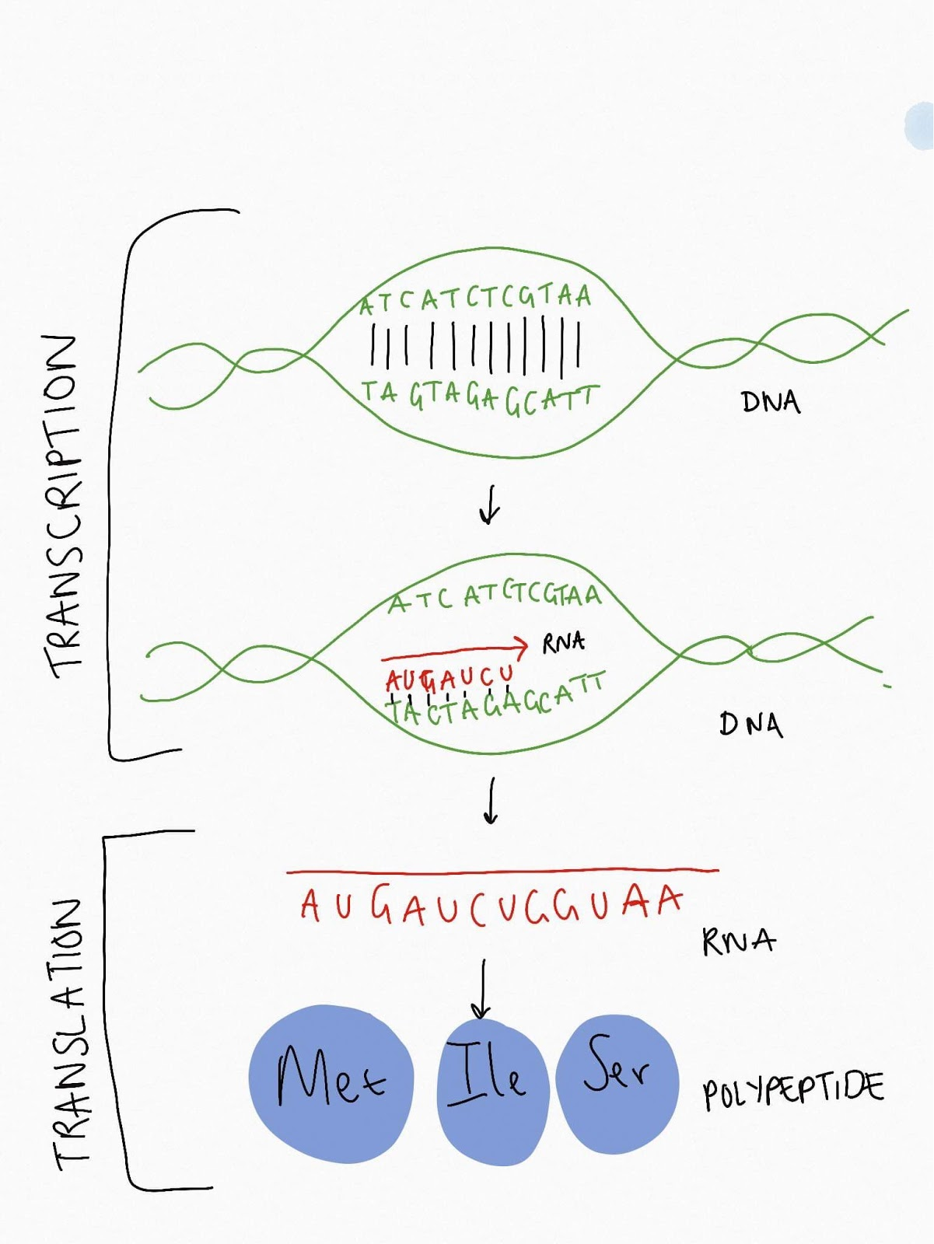
Illustration of the Central Dogma
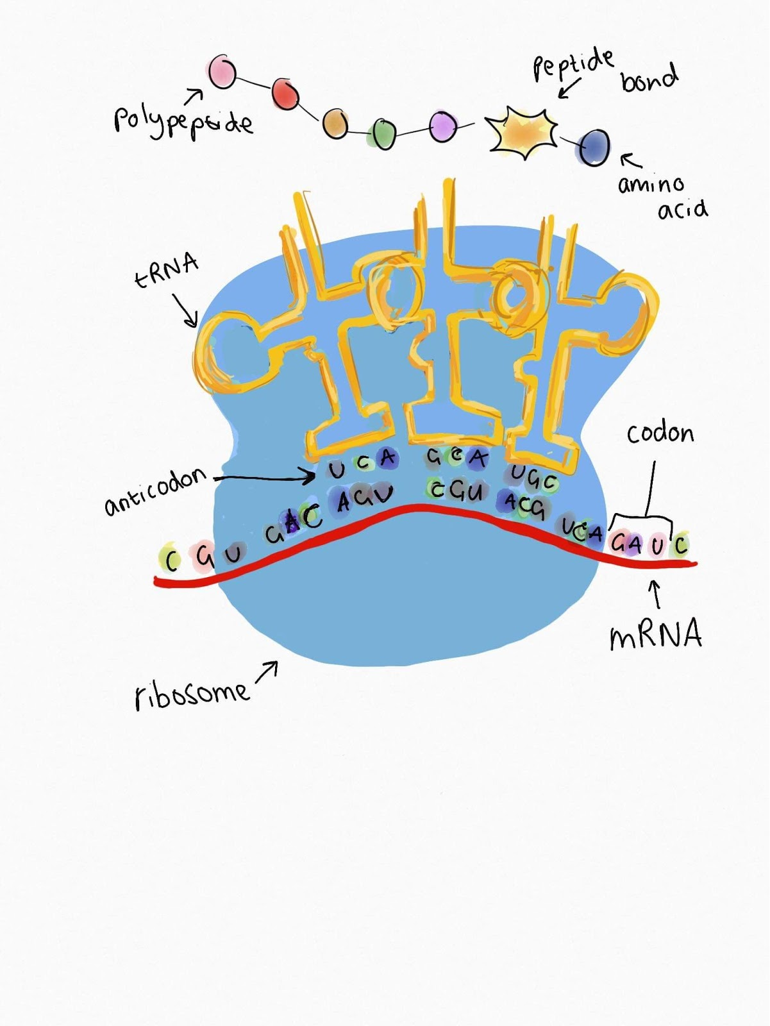
Illustration of Transcription
Teacher Actions
Pre-knowledge and Discussion questions:
You’ve learned that DNA contains our genetic material, but how are those genes expressed?
Where does gene expression take place in a prokaryotic cell?
Where does gene expression take place in a eukaryotic cell? Hint: it is in two places.
What is RNA? What are the differences between RNA and DNA
Do you recognize any similarities between DNA replication and gene expression processes?
What controls gene expression?
- Begin the class by showing this animation
  - https://www.youtube.com/watch?v=gG7uCskUOrA
  - Students should take notes during the video to help answer the discussion and pre-knowledge questions
- Discuss the video with the students
  - What did they see in the video?
  - What did they recognize or already know?
  - What was new information?
- Introduce the information from the background section through reading, research, discussion, and/or lecture
- Students should be able to answer and discuss all the pre-knowledge questions before beginning the activity.
- Transition into the Crack the Code worksheet activity
  - The secret message spells: The key to college is go to class study hard and make friends.
- At the end of class, or for homework, have students reflect on what they’ve learned and how this knowledge can be applied outside of the classroom.

Resources
- https://www.yourgenome.org/facts/what-is-gene-expression
- https://www.nature.com/scitable/topicpage/gene-expression-14121669/
- Illustrations courtesy of Warwick iGEM
- Charts from
  - Adiga, Shashishekar. (2004). Application of molecular modeling to polymer grafted nanostructures.
  - https://www.nature.com/scitable/topicpage/translation-dna-to-mrna-to-protein-393/

Activities
Crack the Code
- Decode the DNA sequence to crack the code!
- Use this diagram to perform the transcription stem and turn your DNA Sequence into an RNA Sequence
  - A becomes U
  - T becomes A
  - G becomes C
  - C becomes G
DNA | RNA
A | U
T | A
G | C
C | G

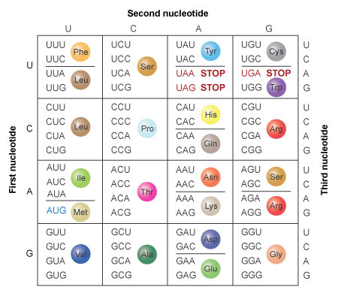
- Next, perform the translation step by “translating” your 3 base RNA sequence into an amino acid. The diagram on the left identifies the amino acid and the chart on the right will tell you its full name.
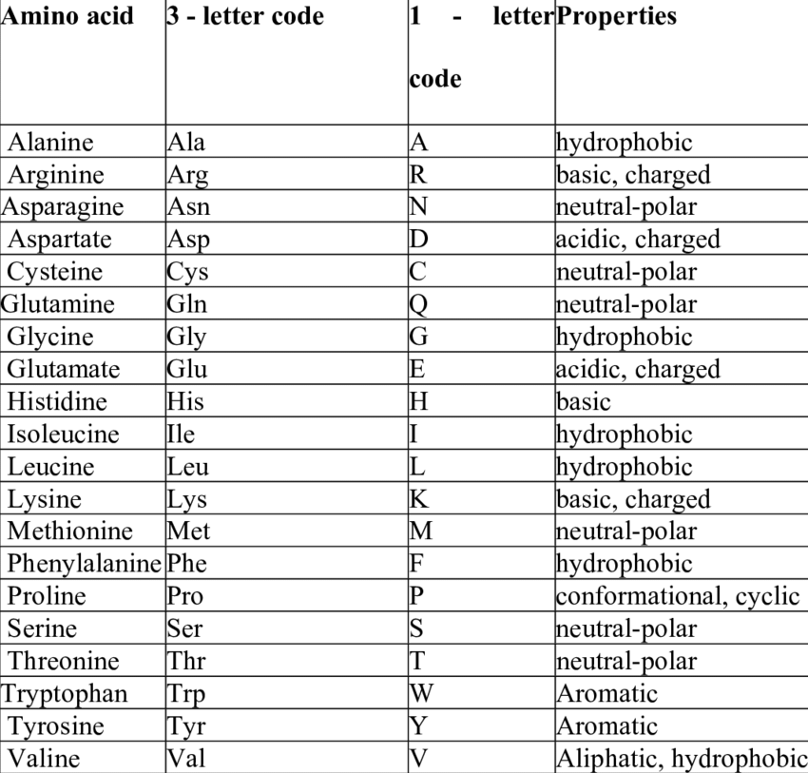

Do not use the 1 letter code in this diagram, use the key on the third page.
- Finally, use the key on the third page to translate the amino acids into a secret message!
DNA Sequence | ATG | CCG | AGT | CTG | TCA | AAT | ATA | GGG | ACG | GGA | CTT
Transcription
Translation
Answer
DNA Sequence | CTC | AGA | CGA | TCA | CGG | TAT | ACT | GGT | ATA | TGG | ACG
Transcription

Translation
Answer
DNA Sequence | CTT | AAA | TAA | TAG | TAG | ATG | TGT | ACC | AAT | CCT | AAG
Transcription
Translation
Answer
DNA Sequence | GTT | ACC | GTG | TCC | ACC | TTA | AAG | CTA | AGT | TAC | GTT
Transcription
Translation
Answer
DNA Sequence | CGT | AGC | GCC | ACC | TAT
Transcription
Translation
Answer

Use this key to translate the amino acids into letters
Phe | Lys | Cys | Trp | Ser | Met | STOP | Gly | Ala | Asp
A | B | C | D | E | F | G | H | I | K
Glu | Asn | Arg | Pro | His | Gln | Ile | Tyr | Thr | Leu
L | M | N | O | P | R | S | T | U | Y

Final Answer:

Genetic Engineering

Relevant SOL
BIO.5 The student will investigate and understand that there are common mechanisms for inheritance. Key ideas include
c) the variety of traits in an organism are the result of the expression of various combinations of alleles;

Learning Objectives
Students will learn about genetic engineering through discussion and a hands on engineering activity.
Students will understand:
- The importance of genetic engineering
- How genetic engineering affects their everyday lives
- Important terms including
  - Plasmid
  - Recombinant DNA
  - Primer
  - CRISPR Cas-9

Background
The next 3 lessons will combine terms and techniques from DNA structure, replication, and Gene expression. Genetic engineering is the process of changing the DNA in an organism's genome. Genetic engineering includes everything changing base pairs in a genome, deleting portions of DNA, and creating more copies of a gene to combining DNA from two organisms’ genome. These techniques are used to control and modify the traits of different organisms in order to form new combinations of beneficial genetic material. Genetic engineering has been used on many organisms from bacteria and viruses to plants to pigs and sheep. You’ve probably encountered, and eaten, genetically modified organisms in your everyday life. In the United States, 93% of soybeans and 88% of corn crops planted are genetically engineered. In this lesson, we will focus on Recombinant DNA Technology in bacteria in viruses which is the joining together of DNA from different organisms and inserting into a host organism to produce new, favorable, genetic combinations.
How does genetic engineering work? We will use insulin producing E. Coli as an example of the genetic engineering process. In insulin producing E. Coli, the human insulin gene, extracted from the pancreas, was inserted into a plasmid which was then transformed into E. Coli. First a favorable gene was identified, the human insulin gene, and extracted from the human genome. This gene was then inserted into a plasmid. A plasmid is a small, circular piece of DNA that replicates independently from the host cell’s chromosomal DNA. Genes are inserted into plasmids through a variety of cloning methods which “cut out” a piece of plasmid DNA, then insert the new gene into that gap. The genetically modified plasmid, often called a vector or a construct, is then transformed into its host cell, E. Coli. As the host cell reproduces, the engineered plasmid will also reproduce and produce insulin.
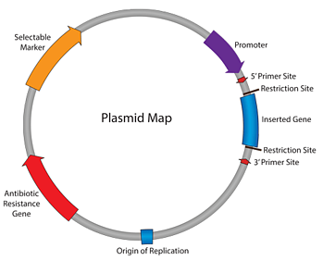
CRISPR Cas9
The CRISPR Cas9 system was modeled after bacterial defense system against phages (viruses that infect bacteria), in which a piece of the phage DNA is inserted into a specific part of the bacteria’s genome. This will allow the bacteria to recognize when it is being attacked by phage again, and it can then withstand the attack. When the virus attacks again, the genome is transcribed by a Cas-9 protein. Then, Cas-9 “searches” the cell for DNA that matches the piece of the saved phage DNA. Once it finds a match, Cas-9 cuts out a piece of the phage DNA, making the phage useless and protecting the bacterium from the attack. Scientists discovered that the CRISPR system is programmable and, after lots of research, has become cheap and relatively simple to achieve. Cas9 can be guided to specific locations on a genome by a short RNA search strand. Once Cas9 is guided to its target, it can cut out the target piece of DNA very precisely.

Teacher Actions
Pre-knowledge questions:
- What is genetic engineering?
- How is genetic engineering used?
- What is a plasmid?
- Begin class by showing this video: https://www.youtube.com/watch?v=jAhjPd4uNFY
  - The first 8 minutes are the most relevant to this lesson, however the video brings up more topics and techniques introduced in the synthetic biology lessons.
  - Screen the video before showing students because it does discuss mature ethical issues.
- Discuss the video with the students
  - What did they see in the video?
  - What did they recognize or already know?
  - What was new information?
- Introduce the information from the background section through reading, research, discussion, and/or lecture
  - The CRISPR Cas-9 section should be covered thoroughly as the topic will be brought up again in the synthetic biology sections
- Students should be able to answer and discuss all of the pre-knowledge questions before beginning the activities
- Transition into the Magnetic Primer Design activity
  - Before beginning the activity, watch this video on DNA sequencing to understand the sequencing process and the importance of primers.
  - https://www.youtube.com/watch?v=ONGdehkB8jU
- Preparations for Activity
  - In order to save time, prepare the DNA template strand before class
    - Students could also make their own template strand
  - To create the DNA template, follow the student protocol, but use 10 magnets
    - The sequence can be all positive (+), all negative (-), or create a random sequence and the students can guess what the template sequence is based on the matches and mismatches of their primers
  - Once each student or group has finished making their primer, they will take turns testing their primer on the DNA template strand
- At the end of class, or for homework, have students reflect on what they’ve learned and how this knowledge can be applied outside of the classroom.

Resources
https://www.yourgenome.org/facts/what-is-genetic-engineering
https://www.teachengineering.org/lessons/view/uoh_genetic_lesson01
https://blog.addgene.org/plasmids-101-what-is-a-plasmid
https://www.fda.gov/food/food-new-plant-varieties/consumer-info-about-food-genetically-engineered-plants
https://www.nature.com/articles/nprot.2013.143
https://www.sciencedirect.com/science/article/pii/S0092867414006047

Activity
Magnetic Primer Design
You’ve engineered a plasmid, but how do you check if the plasmid you transformed is correct? How do you make sure the gene you inserted into the plasmid was successful? Through sequence confirmation in which you replicate a small piece of DNA, sequence it, then analyze the sequence. Primers are necessary to find and replicate the piece of DNA needed for sequencing and further study. In the DNA replication lesson, you learned about the PCR method to replicate targeted DNA sequences. To target these sequences, we use primers to direct DNA polymerase to replicate certain sequences. This activity will teach you to design primers which is a common task in our lab and many other genetics labs.

Materials
- Small, flat magnets (5 per student/group)
- Paint pen or permanent marker in a light color
- Clear tape, 2 inches wide
- Ruler
- Hole Punch
- Paper clip
- Small paper cup
- Pennies, metal washers, or small weights
- Lab notebook or paper for recording results

Procedure
- Arrange the magnets in a stack to identify the north and south pole ends of each magnet
  - Opposites attract so your magnets should be arranged North to South
- Using the paint pen or marker, mark the same pole for each magnet
  - To make sure the same pole is marked on each magnet, mark the top of the magnet then remove it from the stack
- Place a strip of clear packing tape (at least 15 cm long), sticky side up, on a table
- Arrange 5 magnets along one side of the tape 2 cm apart from each other
- Alternate the poles of your magnets in any order you choose.
- Fold the tape over the magnets
- Record the sequence of your primer (+ or -) in your lab notebook
- Test your primer sequence against the DNA template
  - Stick your primer strand to the DNA template. If the magnets stick then it’s a match, if they don’t stick then it’s a mismatch.
  - Record the amount of matches and mismatches in your notebook
- Test the strength of your primer sequence by adding weight to it while it is sticking (annealing) to the template strand.
  - At one end of the primer strand, use a hole punch to put a hole near the end of the tape strip
  - Slip the paperclip through the hole
  - Punch a hole into the side of your paper cup and hang it on the end of the paper clip
  - Stick your primer strand to the DNA template while the cup is attached
  - Hold the template strand so your cup is hanging down and away from the strand
  - Add pennies, washers, or weights one at a time until the strand falls off
  - Record the number of pennies added for the primer strand to fall off
- Compare the strength of your primer with your classmates
  - Who had the strongest primer? Who had the weakest? What was the average number of matches?

Adapted from: https://www.sciencebuddies.org/science-fair-projects/project-ideas/BioChem_p017/biotechnology-techniques/a-magnetic-primer-designer#background

Synthetic Biology

Relevant SOL
BIO.5 The student will investigate and understand that there are common mechanisms for inheritance. Key ideas include
e) synthetic biology has biological and ethical implications

Learning Objectives
Students will learn about synthetic biology through videos, discussion, a research activity, and a hands-on engineering activity.

Background
Synthetic biology is an emerging interdisciplinary field that involves applying engineering principles to biology. Synthetic biology uses the design, build, test framework used in engineering fields to design experiments. Synthetic biology uses genetic engineering as a tool to create living systems. If a cell is a machine, then it’s DNA is the blueprint that creates that machine. Genetic engineering aims to change the blueprint to manipulate the genome. Synthetic biology aims to create a new blueprint that builds life. To accomplish the task of harnessing life, synthetic biology has a few tools. One of the is the biological circuit. Synthetic biology borrowed the concept of a circuit from electrical engineering. A biological circuit is a system of engineered cell parts designed to perform a function. Synthetic biology is more than circuits too. Researchers have been able to synthesize the genome of organisms like E. Coli, and have been able to build a synthetic cell from scratch.

Teacher Actions
Pre-knowledge questions
What is the difference between synthetic biology and genetic engineering?
- Begin class by showing one or both videos
  - Video: https://www.youtube.com/watch?v=7GGi24rMO2Y
  - A look inside a synthetic biology lab: https://www.youtube.com/watch?v=DxoLoOtyllU
- Discuss the video with the students
  - What did they see in the video?
  - What did they recognize or already know?
  - What was new information?
- Introduce the information from the background section through reading, research, discussion, and/or lecture
- Students should be able to answer and discuss all the pre-knowledge questions before beginning the activities
- Transition into the Real-World Projects Activity
- Follow this lesson with the Circuit Builder Enrichment Activity

Resources
https://www.bio.org/articles/synthetic-biology-explained
https://igem.org/About
https://www.sciencedirect.com/science/article/pii/S0167779918302105

Activities
Real World Projects
iGEM is the premier student research competition in synthetic biology. Many advances in the field of synthetic biology and biotechnology companies have come from successful iGEM teams. Therefore, past iGEM projects are valuable resources to analyze, learn from, and improve. In this activity, students will choose a past iGEM project to analyze. Students will identify applications of topics and techniques they have learned an area of the project that could be improved.

Materials
- Computer
- Paper or notebook

Protocol
- Navigate to www.igem.org
- Search team wikis from past competition years
- Choose an interesting project to read and analyze
- Identify applications of topics and techniques you’ve learned in class such as the central dogma
- Find an area of the project that could be improved
- Detail your ideas about how to further develop the project.

Synthetic Biology Ethics

Relevant SOL
BIO.5 The student will investigate and understand that there are common mechanisms for inheritance. Key ideas include
e) synthetic biology has biological and ethical implications

Learning Objectives
Students will learn about issues and ethical questions regarding synthetic and hold a class discussion about these issues and questions.

Teacher Actions
- This final lesson should be in the form of a class debate and/or discussion about the ethics of genetic engineering and synthetic biology. Ethics is a tough, but necessary, topic of research and discussion. Students must be mature and respectful during their research and discussion. Students should approach the discussion using logic and addressing the strengths and flaws in arguments rather than judging the students who present them.
- All the questions and topics listed are suggestions and can be edited depending on the class
- Students should be given time to research the questions below and form a discussion platform before class or before the discussion begins
  - Students should only use resources from academic journals, academic websites, and reputable news centers
  - These three sources are good examples of what to use in their research
    - https://www.wired.com/story/live-forever-synthetic-human-genome/
    - https://www.bbc.com/news/science-environment-48297647
    - https://engineeringbiologycenter.org/about
- Students can research these questions and form their own opinion and platform for discussion. Or, students can be assigned to present for or against a specific argument. The instructor will be the moderator for this discussion.
- It may be beneficial to split students into groups and hold mini discussions in each group, then transition into a whole class discussion.
- Create objectives for the discussion
  - The goal of this discussion is not to find answers to every ethics question. It is to show the students that these issues are complicated and will need an incredible amount of research and discussion to resolve.
- Set an agenda by choose the topics and questions to discuss.
- Provide clear guidelines of what students must do to participate
  - Examples include good sportsmanship, no blurting out opinions, and everyone should have a chance to speak
- Before beginning the discussion, watch this video: https://www.youtube.com/watch?v=jAhjPd4uNFY
  - This is the same video from the genetic engineering lesson. Watch the whole thing or, at least, the last 8 minutes which are the most relevant for this lesson
- The instructor should moderate the class discussion by following the agenda and enforcing the guidelines.
Discussion Questions
- What are some emerging benefits of synthetic biology? What are the risks?
- How much do we really know about DNA and genomes? Do we know enough to safely harness life?
- Historically, how have societies overcome controversies about new, rapidly developing technologies?
- Do synthetic biologists who are modifying organisms that are meant for human consumption have a larger responsibility for their research than most scientists? Why or why not?
- What are the benefits of genetically modified organisms (GMOs)?
- What are the potential negative effects of GMOs?
- We have the technology to edit the human genome and research has already been approved. Should human gene editing be allowed? What are the positives to human gene editing? What could go wrong?
- What happens if we “go too far” with research and experiments? How do you set boundaries for research? Could/Should we prevent research in genetic engineering?
- How should scientists approach these ethical questions?
- Is it morally permissible for scientists to research new methods and technologies without considering the impact their research might have on the public?

